**AIRLINES RESERVATION SYSTM**

IS SUBMITTED TO DEPARTMENT OF COMPUTER APPLICTIONS,



Submitted To: Navneet kaur

Submitted By:

Name of Student: Shivangi Pandey

Reg No: 11813360

GITHUB LINK: <https://github.com/pandeyshivangi/INT-219-Website.git>

VIDEO LINK : <https://drive.google.com/file/d/1ZvCjNDes4XvzWSUWi-440bYt2AFjk8jZ/view?usp=sharing>

1. Project Name and Description

AIRLINES RESERVATION SYSTEM

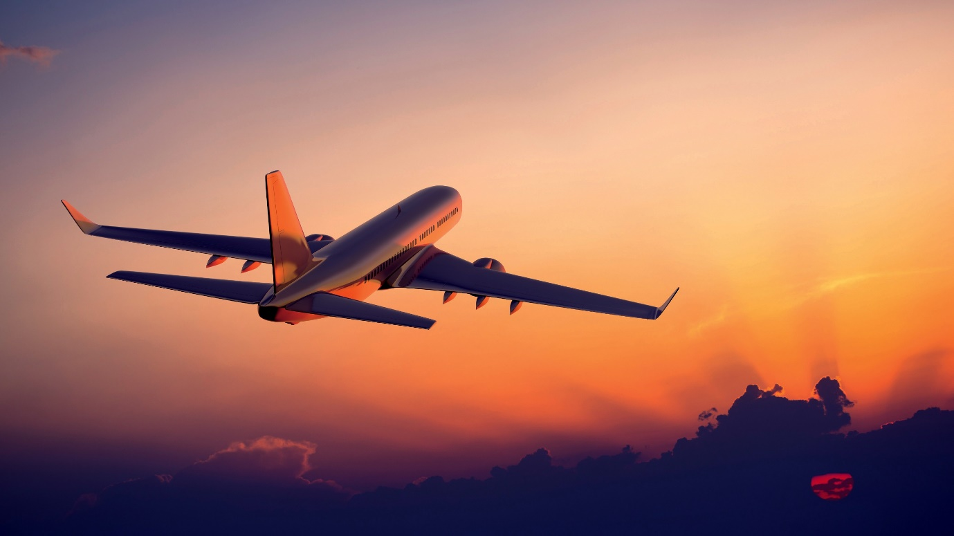

The Airlines Reservation System (ARS) was one of the earlies change to improve efficiency. ARS eventually evolved into the Computer Reservation System (CRS). A interfaces with a Global Distribution System (GDS) which support travel agencies and other distribution channels in making reservation for most airlines in a single system.

Airlines Reservations Systems contain airlines schedules, fare tariffs, own reservation system, as well as pushing out information to the GDS. A second type of direct distribution channel are consumers who use the internet or mobile applications to make their own reservations.

Airline Reservation System contains the details about flight schedules and

its fare tariffs, passenger reservations and ticket records. An airline’s

inventory contains all flights with their available seats. The inventory of an

airline service is generally divided into three category of classes (e.g. First,

Business or Economy class) and each category is having seats up to 26

bookings, along with prices and booking conditions. Inventory data is

imported and maintained through a Schedule Distribution System overstandardized interfaces. One of the core functions of the inventory

management of airline reservations is the inventory control. Inventory

control steers how many seats are available for the different booking

classes, by opening and closing individual booking classes for sale.In

combination with the fares and booking conditions stored in the Fare Quote

System the price for each sold seat is determined.

**PURPOSE:**

Airline Reservation System contains the details about

flight schedules and its fare tariffs, passenger reservations

and ticket records.

The inventory of an airline service is generally divided

into three category of classes (e.g. First, Business or

Economy class) and each category is having seats up to 26

bookings, along with prices and booking conditions.

**USING**

HTML, CSS, JQUERY, MYSQL, JAVASCRIPT, BOOTSTRAP.

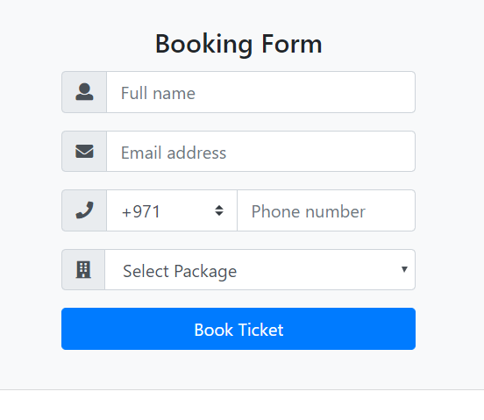

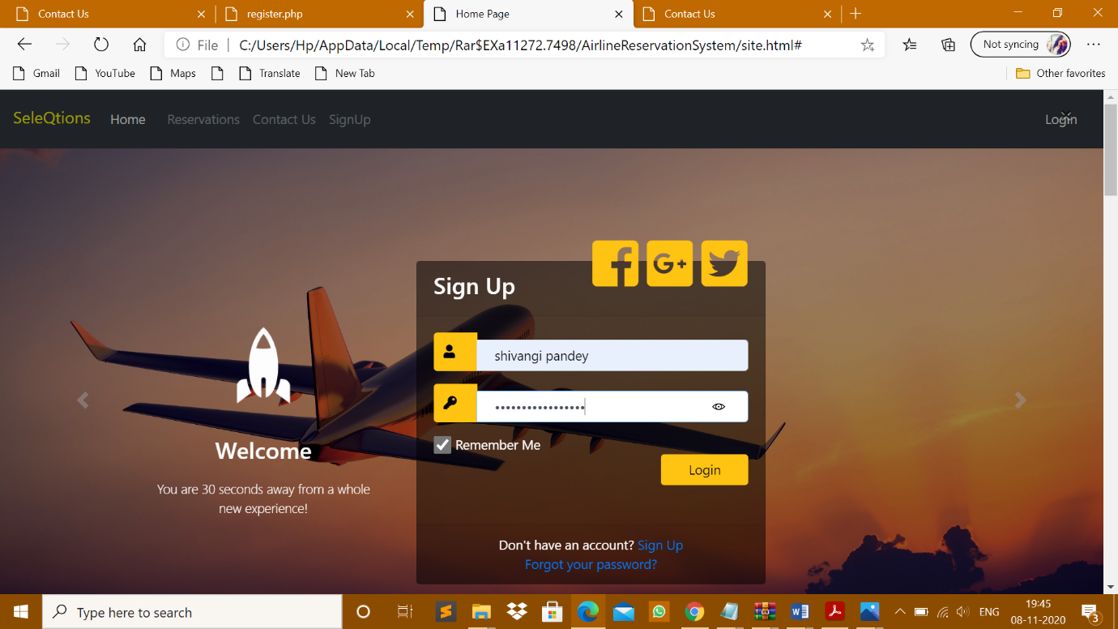

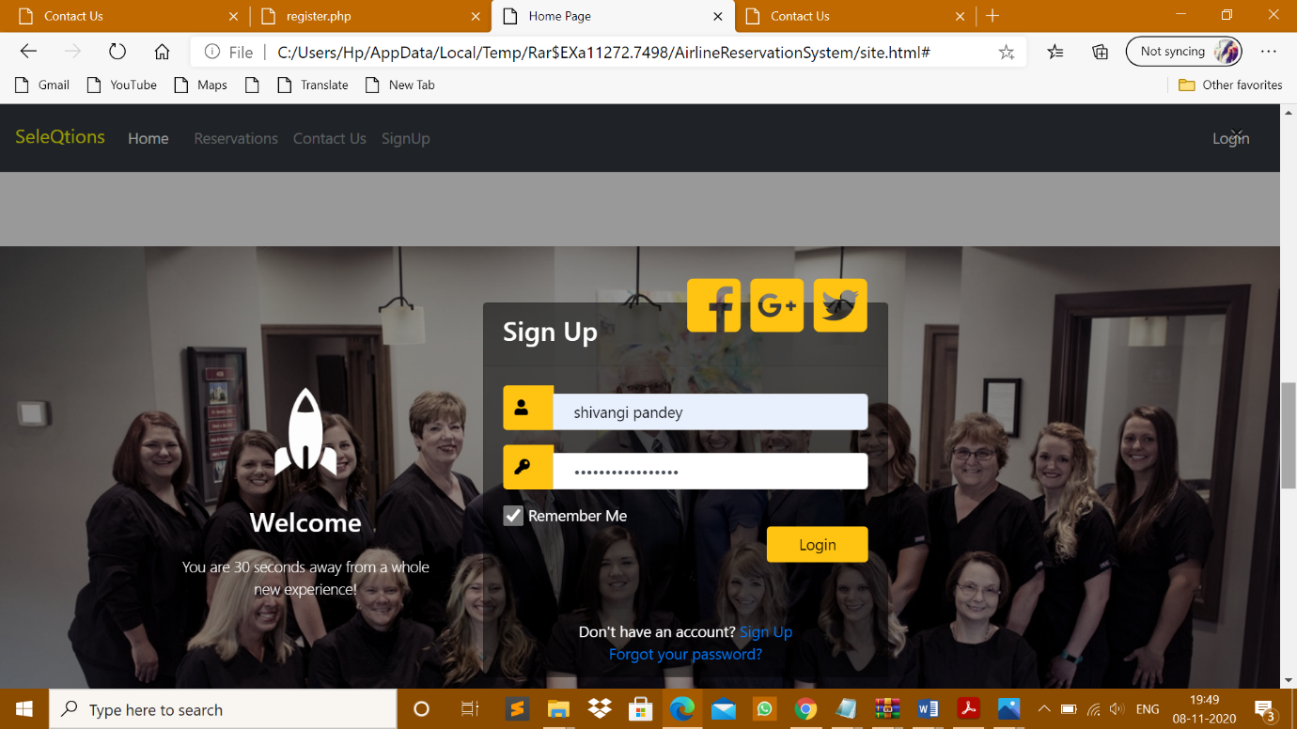

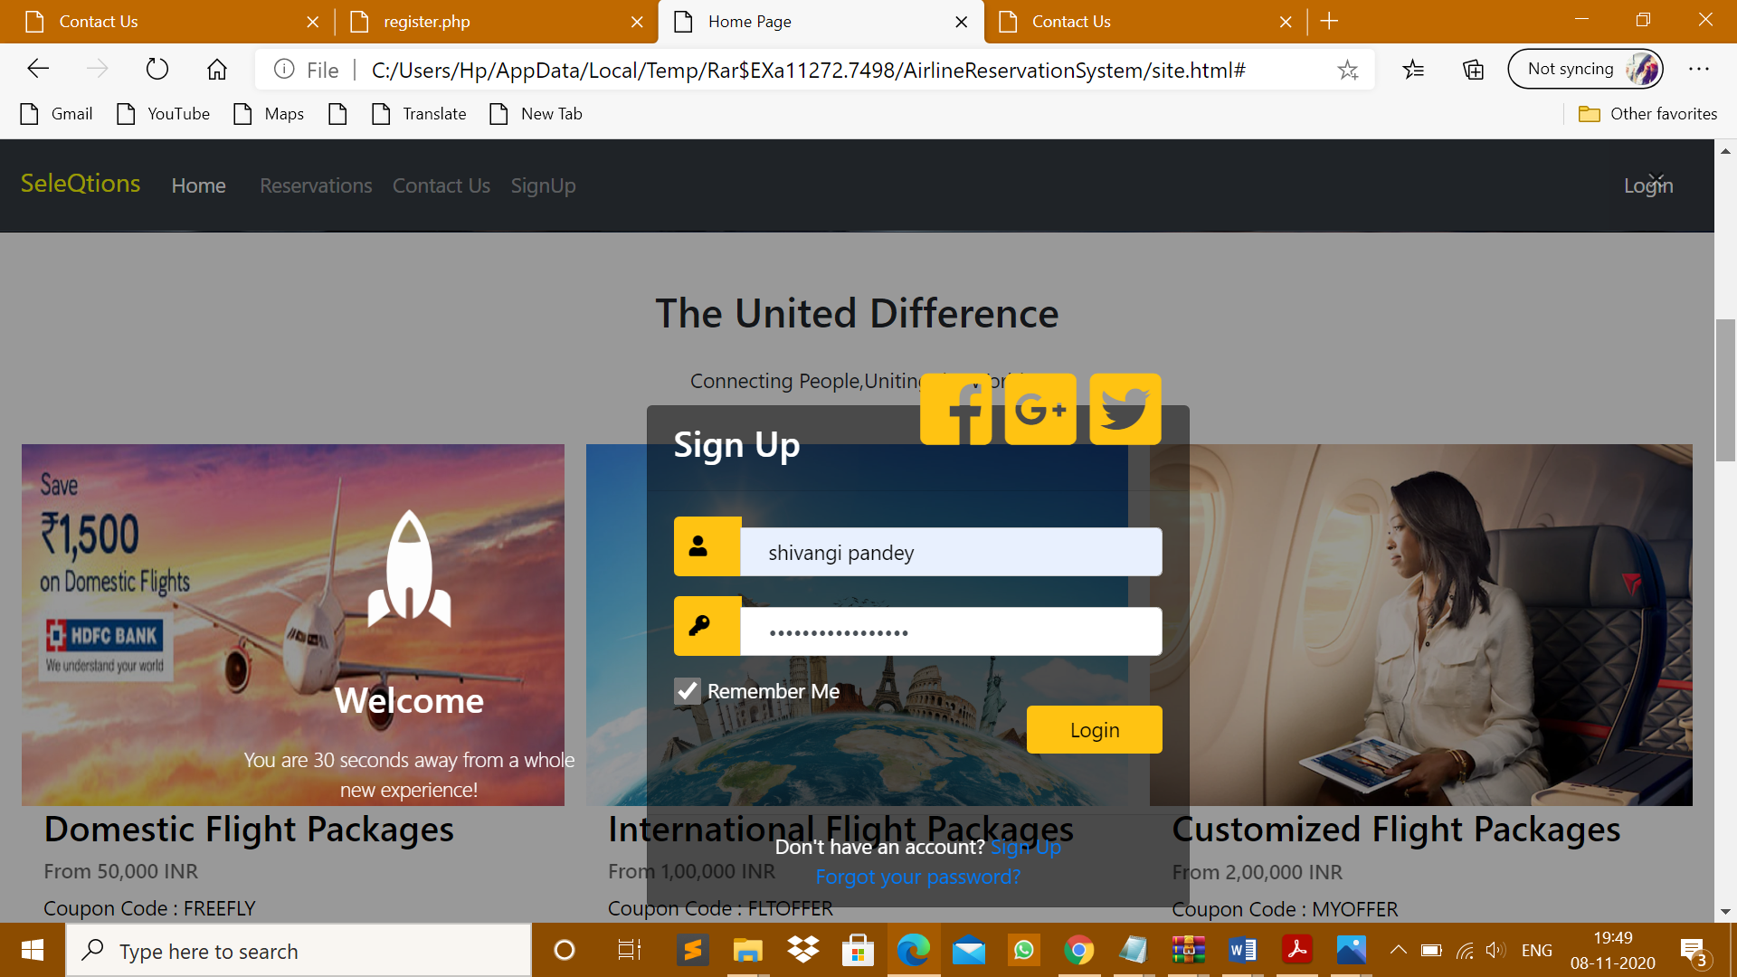

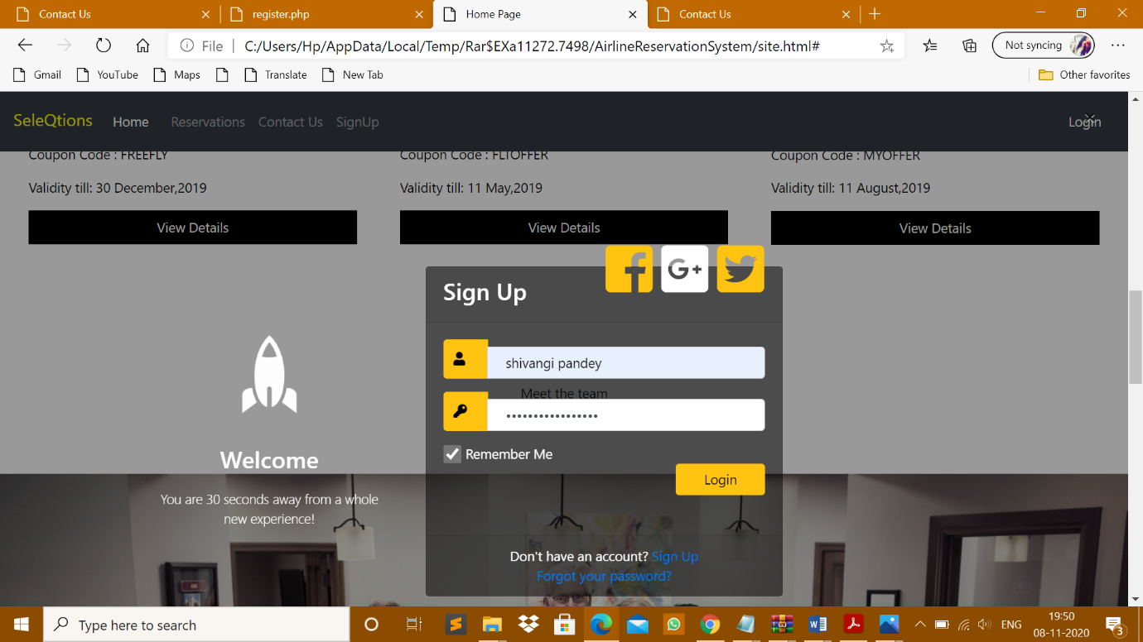

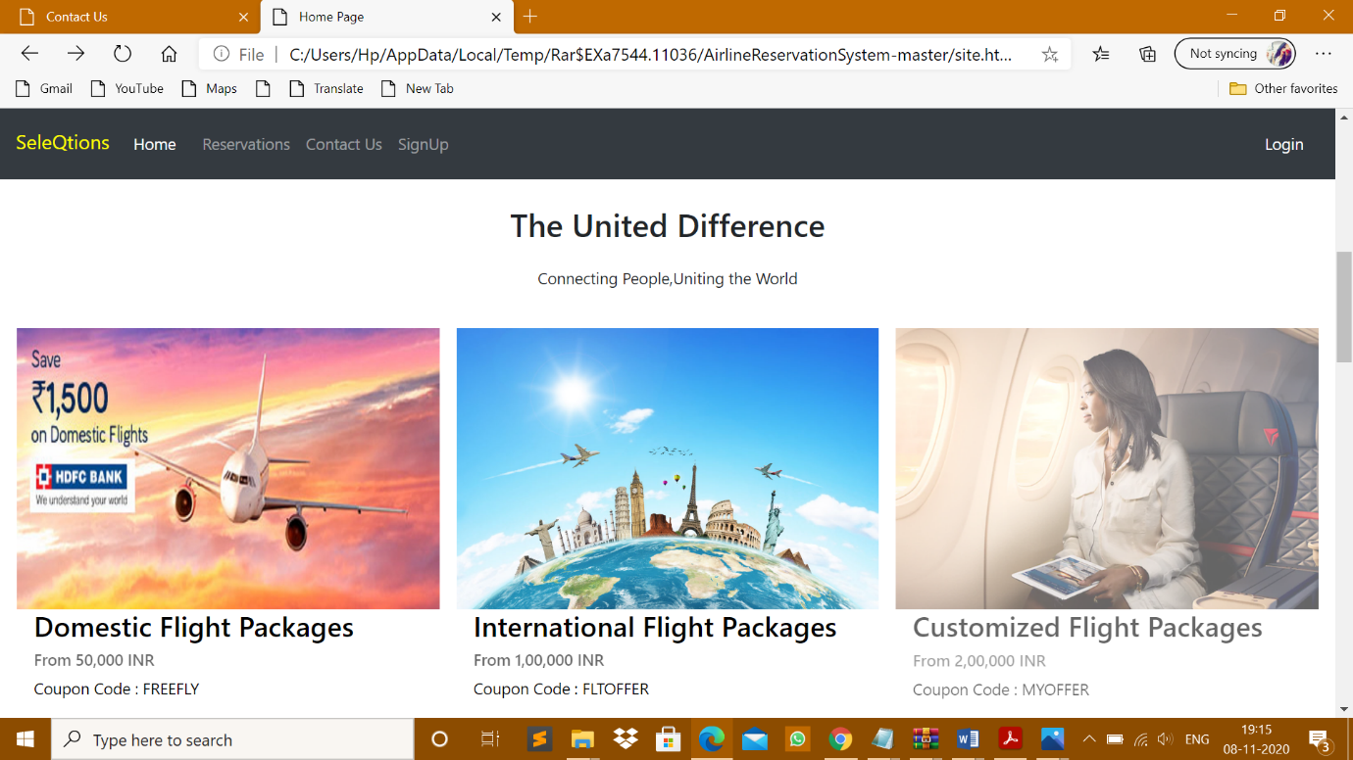

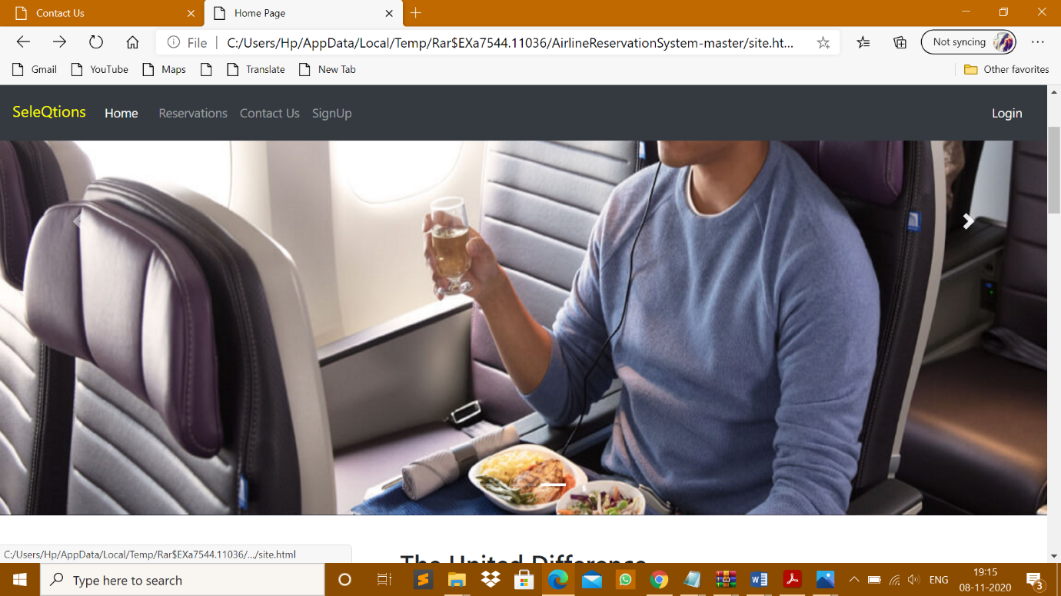

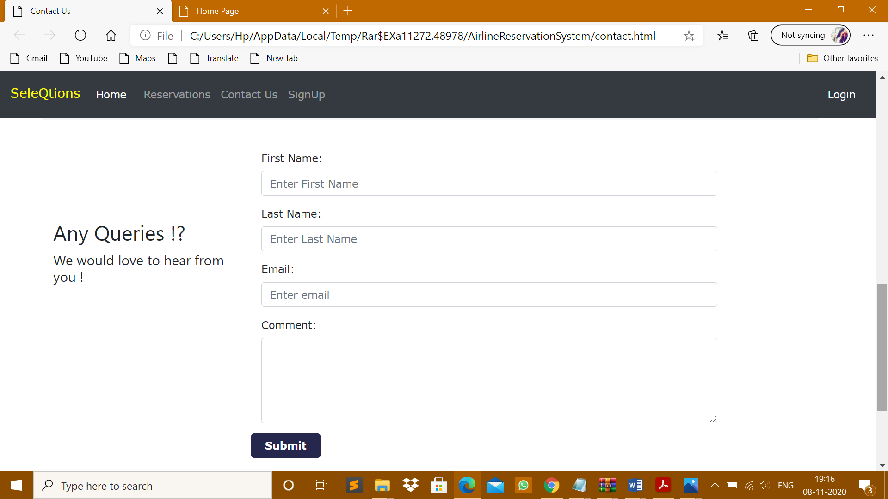

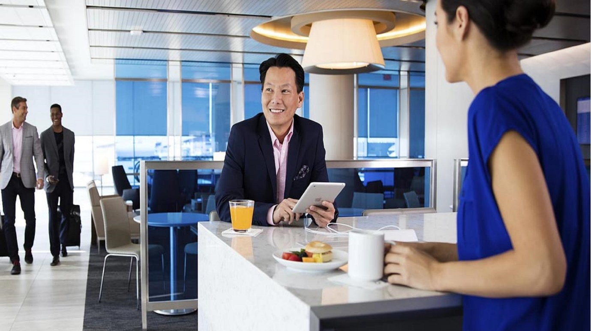

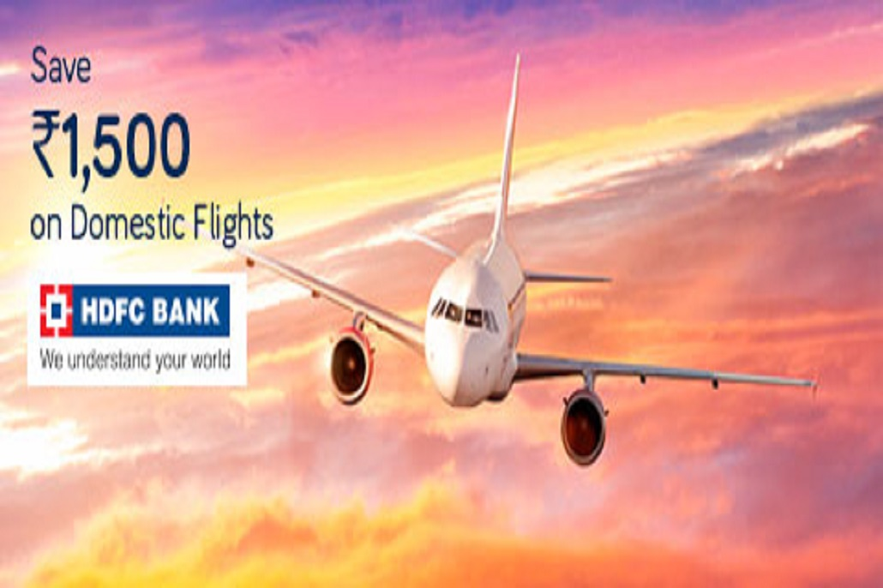

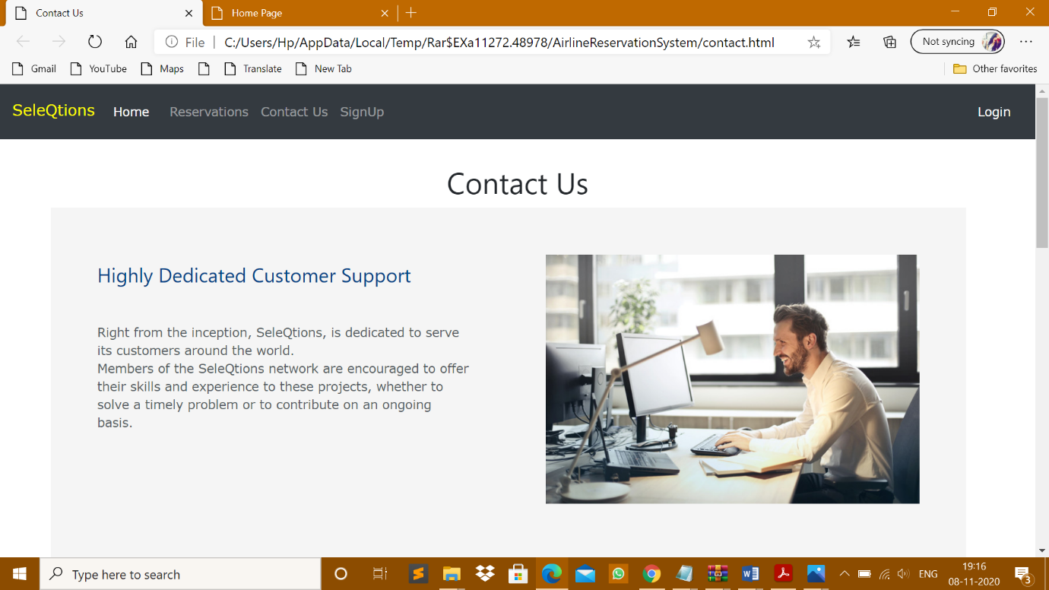



BOOKING FLIGHT:

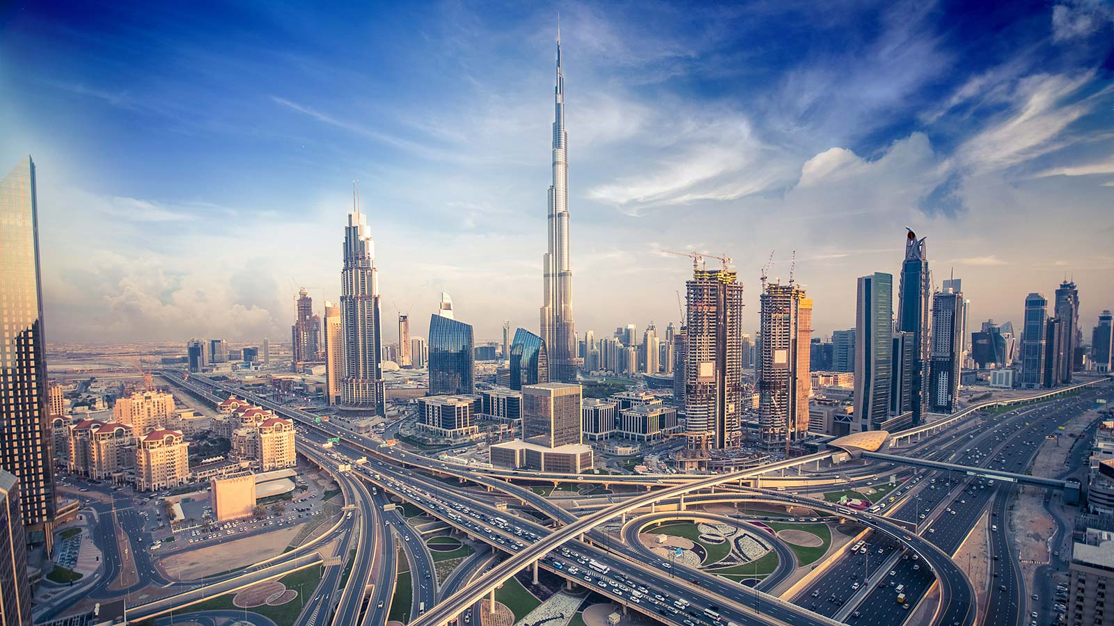

DUBAI :

<!DOCTYPE html>

<html>

<head>

<title>Dubai Packages</title>

<style>

.section .row{

margin-top: 7%;

margin-bottom: 10%;

}

.section .row .col-md-6{

background: #f5f5f5;

margin-right: -2%;

padding: 5%;

}

.section h3{

color: #004085;

}

.section p{

margin-top: 10%;

color: #545b62;

}

.section img

{

width: 100%;

}

.contact-form button{

background: #25274d;

color: #fff;

font-weight: 600;

width: 25%;

}

.contact-info{

margin-top:10%;

}

</style>

</head>

<body>

<?php

if(isset($_SESSION['username']))

{

include "loggedinnav.php";

}

else

{

include "loggedoutnav.php";

}

?>

<br><br><br>

<img src="dubai.jpg">

<br><br>

<br><br>

<h1 style="color: #1A1F71;text-align: center;">Dubai</h1>

<br><p style="color: #5C5C5C;text-align: center; font-size: 25px;">

Dubai city is located within the Dubai emirate of the United Arab Emirates. It is the contemporary playground for the rich and famous, abound with luxury cars and modern skyscrapers glittering in the desert sun. Explore streets filled with old-world Arabian charm at Bur Dubai, or indulge in an out-of-this-world decadent experience in the glamorous Jumeirah district. The vibrant, Arabian metropolis of Dubai city promises to turn your stay into a memorable and enchanting sojourn.</p>

<br><br><br>

<h1 style="color: #1A1F71;text-align: center;">Budget</h1><br><br>

<p style="color: #5C5C5C;text-align: center; font-size: 25px;">

The local currency in Dubai is the United Arab Emirates Dirham (AED).<br>

Based on trip type, your average daily budget would be<br>

Budget – 1200 AED<br>

Standard – 3400 AED<br>

Premium – 6700 AED</p>

<br><br><br>

<div class="row" style="margin:auto;">

<span style="padding-right: 25%"></span>

<div class="col-md-6 text-center">

<div class="card-deck">

<div class="card">

<img src="https://www.visa.co.in/dam/VCOM/regional/ap/images/icon-destinations-hotel-110x110.jpg" class="card-img-top" alt="...">

<div class="card-body">

<h5 class="card-title">4 star hotel</h5>

<p class="card-text">1286 AED</p>

</div>

</div>

<div class="card" style="padding-left: 40px;">

<img src="https://www.visa.co.in/dam/VCOM/regional/ap/images/icon-destinations-taxi-110x110.jpg" class="card-img-top" alt="...">

<div class="card-body">

<h5 class="card-title">Taxi per km</h5>

<p class="card-text">3 AED</p>

</div>

</div>

<div class="card" style="padding-left:40px; ">

<img src="https://www.visa.co.in/dam/VCOM/regional/ap/images/icon-destinations-local-coffee-110x110.jpg" class="card-img-top" alt="...">

<div class="card-body">

<h5 class="card-title">Cup of local coffee</h5>

<p class="card-text">7 AED</p>

</div>

</div>

<div class="card" style="padding-left: 40px; ">

<img src="https://www.visa.co.in/dam/VCOM/regional/ap/images/icon-destinations-meal-110x110.jpg" class="card-img-top" alt="...">

<div class="card-body">

<h5 class="card-title">Standard meal</h5>

<p class="card-text">200 AED</p>

</div>

</div>

</div>

</div>

</div>

<br><br>

<div style="background-color: #1A1F71">

<br><h2 style="color: #fc0;text-align: center;">Need help in Dubai?</h2>

<br><br>

<div style="color: white;text-align: center;font-size:20px">SeleQtion's Global Customer Assistance Service is available 24 hours a day, 7 days a week. <br><br> In Dubai, call our freephone number: Access Code 8000 121 then 866 654 0112<br><br> Or call +1 303 967 1090 from anywhere in the world. </div><br><br>

</div><br>

<!-- Button trigger modal -->

<button type="button" class="btn btn-primary" data-toggle="modal" data-target="#exampleModal">

Book Now

</button>

<!-- Modal -->

<div class="modal fade" id="exampleModal" tabindex="-1" role="dialog" aria-labelledby="exampleModalLabel" aria-hidden="true">

<div class="modal-dialog" role="document">

<div class="modal-content">

<div class="modal-header">

<button type="button" class="close" data-dismiss="modal" aria-label="Close">

<span aria-hidden="true">&times;</span>

</button>

</div>

<div class="modal-body">

<?php include "bookingform.php"?>

</div>

</div>

</div>

</div>

<br><br>

<footer class="w3-padding-32 w3-black w3-center w3-margin-top">

<h5>Find Us On</h5>

<div class="w3-xlarge w3-padding-16">

<i class="fa fa-facebook-official w3-hover-opacity"></i>

<i class="fa fa-instagram w3-hover-opacity"></i>

<i class="fa fa-pinterest-p w3-hover-opacity"></i>

<i class="fa fa-twitter w3-hover-opacity"></i>

</div>

<p>Developed by <a href="#" target="_blank" class="w3-hover-text-green">Shivangi Pandey</a></p>

</footer>

</body>

</html>

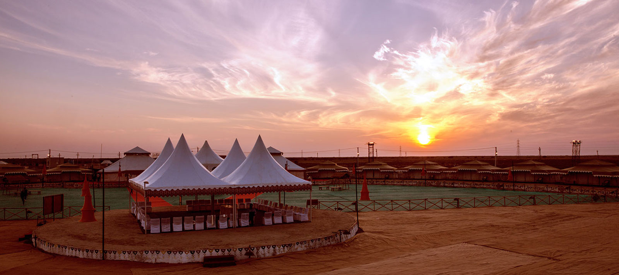

GUJRAT:

<!DOCTYPE html>

<html>

<head>

<title>Gujarat and Goa Packages</title>

<style>

.section .row{

margin-top: 7%;

margin-bottom: 10%;

}

.section .row .col-md-6{

background: #f5f5f5;

margin-right: -2%;

padding: 5%;

}

.section h3{

color: #004085;

}

.section p{

margin-top: 10%;

color: #545b62;

}

.section img

{

width: 100%;

}

.contact-form button{

background: #25274d;

color: #fff;

font-weight: 600;

width: 25%;

}

.contact-info{

margin-top:10%;

}

</style>

</head>

<body>

<?php

if(isset($_SESSION['username']))

{

include "loggedinnav.php";

}

else

{

include "loggedoutnav.php";

}

?>

<br><br><br>

<div style="position: relative;">

<img src="guj.jpg">

<img src="Capture1.PNG" style="position:absolute;z-index:1;top:70;right:100">

</div>

<br><br>

<br><br>

<h1 style="color: #1A1F71;text-align: center;">Gujarat and Goa</h1>

<br><p style="color: #5C5C5C;text-align: center; font-size: 30px;">

Gujarat, India's westernmost state, has varied terrain and numerous sacred sites. In its urban center of Ahmedabad is the Calico Museum of Textiles, displaying antique and modern Indian fabrics.<br>

Goa is a state in western India with coastlines stretching along the Arabian Sea. Its long history as a Portuguese colony.

</p>

<br><br><br>

<h1 style="color: #1A1F71;text-align: center;">Budget</h1><br><br>

<p style="color: #5C5C5C;text-align: center; font-size: 30px;">

The local currency in Gujarat and Goa is the Indian Rupees (INR).<br>

Based on trip type, your average daily budget would be<br>

Budget – 1200 INR<br>

Standard – 1550 INR<br>

Premium – 2500 INR</p>

<br><br><br>

<div class="row" style="margin:auto;">

<span style="padding-right: 25%"></span>

<div class="col-md-6 text-center">

<div class="card-deck">

<div class="card">

<img src="https://www.visa.co.in/dam/VCOM/regional/ap/images/icon-destinations-hotel-110x110.jpg" class="card-img-top" alt="...">

<div class="card-body">

<h5 class="card-title">4 star hotel</h5>

<p class="card-text">1400 INR</p>

</div>

</div>

<div class="card" style="padding-left: 40px;">

<img src="https://www.visa.co.in/dam/VCOM/regional/ap/images/icon-destinations-taxi-110x110.jpg" class="card-img-top" alt="...">

<div class="card-body">

<h5 class="card-title">Taxi per km</h5>

<p class="card-text">20 INR</p>

</div>

</div>

<div class="card" style="padding-left:40px; ">

<img src="https://www.visa.co.in/dam/VCOM/regional/ap/images/icon-destinations-local-coffee-110x110.jpg" class="card-img-top" alt="...">

<div class="card-body">

<h5 class="card-title">Cup of local coffee</h5>

<p class="card-text">15 INR</p>

</div>

</div>

<div class="card" style="padding-left: 40px; ">

<img src="https://www.visa.co.in/dam/VCOM/regional/ap/images/icon-destinations-meal-110x110.jpg" class="card-img-top" alt="...">

<div class="card-body">

<h5 class="card-title">Standard meal</h5>

<p class="card-text">300 INR</p>

<!DOCTYPE html>

<html>

<head>

<title>Domestic Packages</title>

<script src="//maxcdn.bootstrapcdn.com/bootstrap/4.1.1/js/bootstrap.min.js"></script>

<script src="//cdnjs.cloudflare.com/ajax/libs/jquery/3.2.1/jquery.min.js"></script>

<link rel="stylesheet" href="https://stackpath.bootstrapcdn.com/bootstrap/4.3.1/css/bootstrap.min.css" integrity="sha384-ggOyR0iXCbMQv3Xipma34MD+dH/1fQ784/j6cY/iJTQUOhcWr7x9JvoRxT2MZw1T" crossorigin="anonymous">

<script src="https://code.jquery.com/jquery-3.3.1.slim.min.js" integrity="sha384-q8i/X+965DzO0rT7abK41JStQIAqVgRVzpbzo5smXKp4YfRvH+8abtTE1Pi6jizo" crossorigin="anonymous"></script>

<script src="https://cdnjs.cloudflare.com/ajax/libs/popper.js/1.14.7/umd/popper.min.js" integrity="sha384-UO2eT0CpHqdSJQ6hJty5KVphtPhzWj9WO1clHTMGa3JDZwrnQq4sF86dIHNDz0W1" crossorigin="anonymous"></script>

<script src="https://stackpath.bootstrapcdn.com/bootstrap/4.3.1/js/bootstrap.min.js" integrity="sha384-JjSmVgyd0p3pXB1rRibZUAYoIIy6OrQ6VrjIEaFf/nJGzIxFDsf4x0xIM+B07jRM" crossorigin="anonymous"></script>

<meta name="viewport" content="width=device-width, initial-scale=1">

<link rel="stylesheet" href="https://cdnjs.cloudflare.com/ajax/libs/font-awesome/4.7.0/css/font-awesome.min.css">

<link rel="stylesheet" href="https://www.w3schools.com/w3css/4/w3.css">

<link href="//maxcdn.bootstrapcdn.com/bootstrap/4.1.1/css/bootstrap.min.css" rel="stylesheet" id="bootstrap-css">

<script src="//maxcdn.bootstrapcdn.com/bootstrap/4.1.1/js/bootstrap.min.js"></script>

<script src="//cdnjs.cloudflare.com/ajax/libs/jquery/3.2.1/jquery.min.js"></script>

<link rel="stylesheet" href="https://cdnjs.cloudflare.com/ajax/libs/font-awesome/4.7.0/css/font-awesome.min.css">

<link rel="stylesheet" type="text/css" href="style.css">

<style>

.section .row{

margin-top: 7%;

margin-bottom: 10%;

}

.section .row .col-md-6{

background: #f5f5f5;

margin-right: -2%;

padding: 5%;

}

.section h3{

color: #004085;

}

.section p{

margin-top: 10%;

color: #545b62;

}

.section img

{

width: 100%;

}

.contact-form button{

background: #25274d;

color: #fff;

font-weight: 600;

width: 25%;

}

.contact-info{

margin-top:10%;

}

</style>

</head>

<body>

<?php

if(isset($_SESSION['username']))

{

include "loggedinnav.php";

}

else

{

include "loggedoutnav.php";

}

?>

<br><br><br>

<img src="pic1.jpg">

<br><br>

<br><br>

<h1 style="color: #1A1F71;text-align: center;">Domestic Packages</h1>

<br><p style="color: #5C5C5C;text-align: center;">

SeleQtions has a wide range of domestic packages for you to select. <br>Explore our wide range of budget-friendly airline packages right from Delhi to Kanyakumari and from Ahmedabad to Orissa</p>

<br><br><br>

<div class="card-deck">

<div class="card text-center" >

<img src="maharashtra.jpg" class="card-img-top" alt="..." height="280px">

<div class="card-body">

<h5 class="card-title" style="color: #1A1F71">Maharashtra</h5>

<p class="card-text" style="color: #5C5C5C">Get,set Go for a wonderful 3-day 4-night package of various tourist destinations in Maharashtra.</p>

<a href="maharashtra.php" class="btn btn-primary" style="text-align: center;">View Packages</a>

</div>

</div>

<div class="card text-center" >

<img src="goa.jpg" class="card-img-top" alt="..." height="280px">

<div class="card-body">

<h5 class="card-title"style="color: #1A1F71">Gujarat and Goa</h5>

<p class="card-text" style="color: #5C5C5C">Gujarat and Goa, a cosmopolitan meeting of West and Central West.Relax at the beaches of Goa.</p>

<a href="gujarat.php" class="btn btn-primary" style="text-align: center;">View Packages</a>

</div>

</div>

<div class="card text-center">

<img src="tel.jpg" class="card-img-top" alt="..." height="280px">

<div class="card-body">

<h5 class="card-title" style="color: #1A1F71">Telangana and Andhra Pradesh</h5>

<p class="card-text" style="color: #5C5C5C">Telangana and Andhra Pradesh, where Tradition, Culture and the Future meet.</p>

<a href="tel.php" class="btn btn-primary" style="text-align: center;">View Packages</a>

</div>

</div>

</div>

<br><br>

<footer class="w3-padding-32 w3-black w3-center w3-margin-top">

<h5>Find Us On</h5>

<div class="w3-xlarge w3-padding-16">

<i class="fa fa-facebook-official w3-hover-opacity"></i>

<i class="fa fa-instagram w3-hover-opacity"></i>

<i class="fa fa-pinterest-p w3-hover-opacity"></i>

<i class="fa fa-twitter w3-hover-opacity"></i>

</div>

<p>Developed by <a href="#" target="_blank" class="w3-hover-text-green">Shivangi Pandey</a></p>

</footer>

</body>

</html>

<!DOCTYPE html>

<html>

<head>

<title>Domestic Packages</title>

<script src="//maxcdn.bootstrapcdn.com/bootstrap/4.1.1/js/bootstrap.min.js"></script>

<script src="//cdnjs.cloudflare.com/ajax/libs/jquery/3.2.1/jquery.min.js"></script>

<link rel="stylesheet" href="https://stackpath.bootstrapcdn.com/bootstrap/4.3.1/css/bootstrap.min.css" integrity="sha384-ggOyR0iXCbMQv3Xipma34MD+dH/1fQ784/j6cY/iJTQUOhcWr7x9JvoRxT2MZw1T" crossorigin="anonymous">

<script src="https://code.jquery.com/jquery-3.3.1.slim.min.js" integrity="sha384-q8i/X+965DzO0rT7abK41JStQIAqVgRVzpbzo5smXKp4YfRvH+8abtTE1Pi6jizo" crossorigin="anonymous"></script>

<script src="https://cdnjs.cloudflare.com/ajax/libs/popper.js/1.14.7/umd/popper.min.js" integrity="sha384-UO2eT0CpHqdSJQ6hJty5KVphtPhzWj9WO1clHTMGa3JDZwrnQq4sF86dIHNDz0W1" crossorigin="anonymous"></script>

<script src="https://stackpath.bootstrapcdn.com/bootstrap/4.3.1/js/bootstrap.min.js" integrity="sha384-JjSmVgyd0p3pXB1rRibZUAYoIIy6OrQ6VrjIEaFf/nJGzIxFDsf4x0xIM+B07jRM" crossorigin="anonymous"></script>

<meta name="viewport" content="width=device-width, initial-scale=1">

<link rel="stylesheet" href="https://cdnjs.cloudflare.com/ajax/libs/font-awesome/4.7.0/css/font-awesome.min.css">

<link rel="stylesheet" href="https://www.w3schools.com/w3css/4/w3.css">

<link href="//maxcdn.bootstrapcdn.com/bootstrap/4.1.1/css/bootstrap.min.css" rel="stylesheet" id="bootstrap-css">

<script src="//maxcdn.bootstrapcdn.com/bootstrap/4.1.1/js/bootstrap.min.js"></script>

<script src="//cdnjs.cloudflare.com/ajax/libs/jquery/3.2.1/jquery.min.js"></script>

<link rel="stylesheet" href="https://cdnjs.cloudflare.com/ajax/libs/font-awesome/4.7.0/css/font-awesome.min.css">

<link rel="stylesheet" type="text/css" href="style.css">

<style>

.section .row{

margin-top: 7%;

margin-bottom: 10%;

}

.section .row .col-md-6{

background: #f5f5f5;

margin-right: -2%;

padding: 5%;

}

.section h3{

color: #004085;

}

.section p{

margin-top: 10%;

color: #545b62;

}

.section img

{

width: 100%;

}

.contact-form button{

background: #25274d;

color: #fff;

font-weight: 600;

width: 25%;

}

.contact-info{

margin-top:10%;

}

</style>

</head>

<body>

<?php

if(isset($_SESSION['username']))

{

include "loggedinnav.php";

}

else

{

include "loggedoutnav.php";

}

?>

<br><br><br>

<img src="pic1.jpg">

<br><br>

<br><br>

<h1 style="color: #1A1F71;text-align: center;">Domestic Packages</h1>

<br><p style="color: #5C5C5C;text-align: center;">

SeleQtions has a wide range of domestic packages for you to select. <br>Explore our wide range of budget-friendly airline packages right from Delhi to Kanyakumari and from Ahmedabad to Orissa</p>

<br><br><br>

<div class="card-deck">

<div class="card text-center" >

<img src="maharashtra.jpg" class="card-img-top" alt="..." height="280px">

<div class="card-body">

<h5 class="card-title" style="color: #1A1F71">Maharashtra</h5>

<p class="card-text" style="color: #5C5C5C">Get,set Go for a wonderful 3-day 4-night package of various tourist destinations in Maharashtra.</p>

<a href="maharashtra.php" class="btn btn-primary" style="text-align: center;">View Packages</a>

</div>

</div>

<div class="card text-center" >

<img src="goa.jpg" class="card-img-top" alt="..." height="280px">

<div class="card-body">

<h5 class="card-title"style="color: #1A1F71">Gujarat and Goa</h5>

<p class="card-text" style="color: #5C5C5C">Gujarat and Goa, a cosmopolitan meeting of West and Central West.Relax at the beaches of Goa.</p>

<a href="gujarat.php" class="btn btn-primary" style="text-align: center;">View Packages</a>

</div>

</div>

<div class="card text-center">

<img src="tel.jpg" class="card-img-top" alt="..." height="280px">

<div class="card-body">

<h5 class="card-title" style="color: #1A1F71">Telangana and Andhra Pradesh</h5>

<p class="card-text" style="color: #5C5C5C">Telangana and Andhra Pradesh, where Tradition, Culture and the Future meet.</p>

<a href="tel.php" class="btn btn-primary" style="text-align: center;">View Packages</a>

</div>

</div>

</div>

<br><br>

<footer class="w3-padding-32 w3-black w3-center w3-margin-top">

<h5>Find Us On</h5>

<div class="w3-xlarge w3-padding-16">

<i class="fa fa-facebook-official w3-hover-opacity"></i>

<i class="fa fa-instagram w3-hover-opacity"></i>

<i class="fa fa-pinterest-p w3-hover-opacity"></i>

<i class="fa fa-twitter w3-hover-opacity"></i>

</div>

<p>Developed by <a href="#" target="_blank" class="w3-hover-text-green">Shivangi Pandey</a></p>

</footer>

</body>

</html>